Canada Mondioring Association Club Membership Application Form

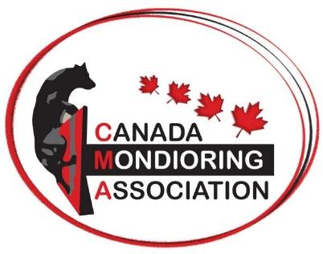

CMA Club Application Form

Club Name:
Address:
Postal Code:
Email/Facebook Page/Website:

Club Members Currently Members of CMA (min. 3 CMA members)

Primary Contact:

CMA Member 2:

CMA Member 3:

Other CMA Members:

Date Submitted:
*MUST ATTACH CLUB BY-LAWS FOR APPROVAL

